**Configure YAML**

Download Link:

yaml：[GitHub - jbeder/yaml-cpp: A YAML parser and emitter in C++](https://github.com/jbeder/yaml-cpp)[1]

CMAKE: https://cmake.org/download/

1. Install CMAKE

Check Add CMAKE to your system path

After the installation is completed and the computer is restarted, open the cmd black window and enter “cmake”. If some information about cmake is displayed, the installation is successful, as shown below

1. Log in to the yaml website [1], download the source code and unzip it

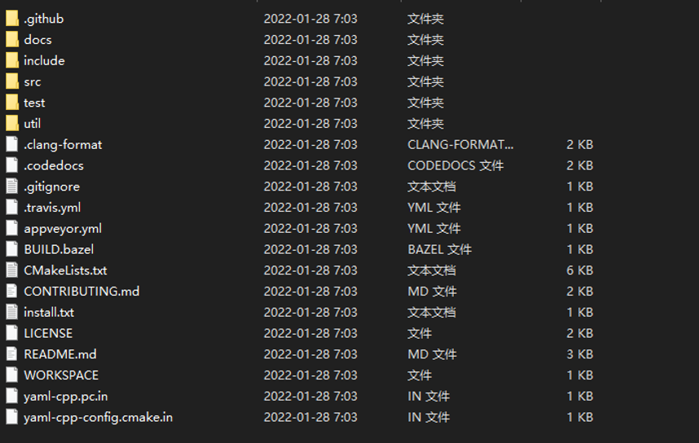

1. Start Build yaml: Create a build folder in the path where the source code is located, open CMAKE, and select the SORCE CODE path and BUILD path respectively, as shown below

Then click the Configure button below and wait for completion. Select the corresponding VS compiler version. The author is VS2019. When Configuring done appears, it is successful.

Next, select **YAML_CPP_BUILD_SHARED_LIB**, create a new lib folder in the yaml-cpp-master/ directory and change the **CMAKE_INSTALL_PREFIX** item to the newly created lib directory (not necessary, just for management convenience). Click Generate and “Generating done” will appear.

You can see that the corresponding make results appear in the build folder.

Next click Open Project, open VS, and then use Debug mode and Release mode to generate projects.

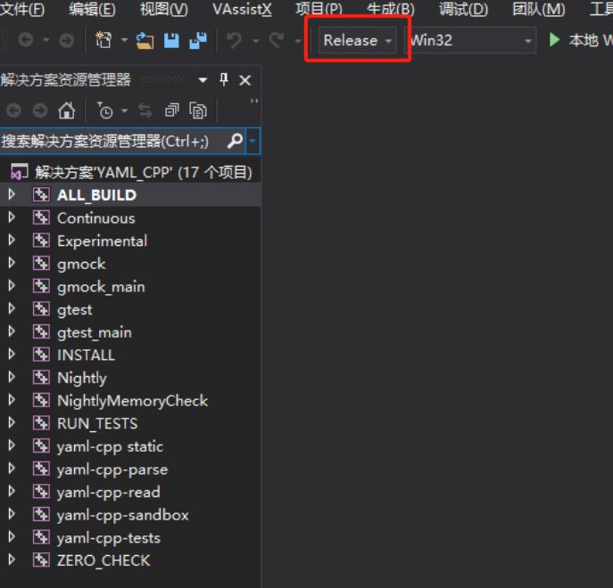

You can see the generated folder:

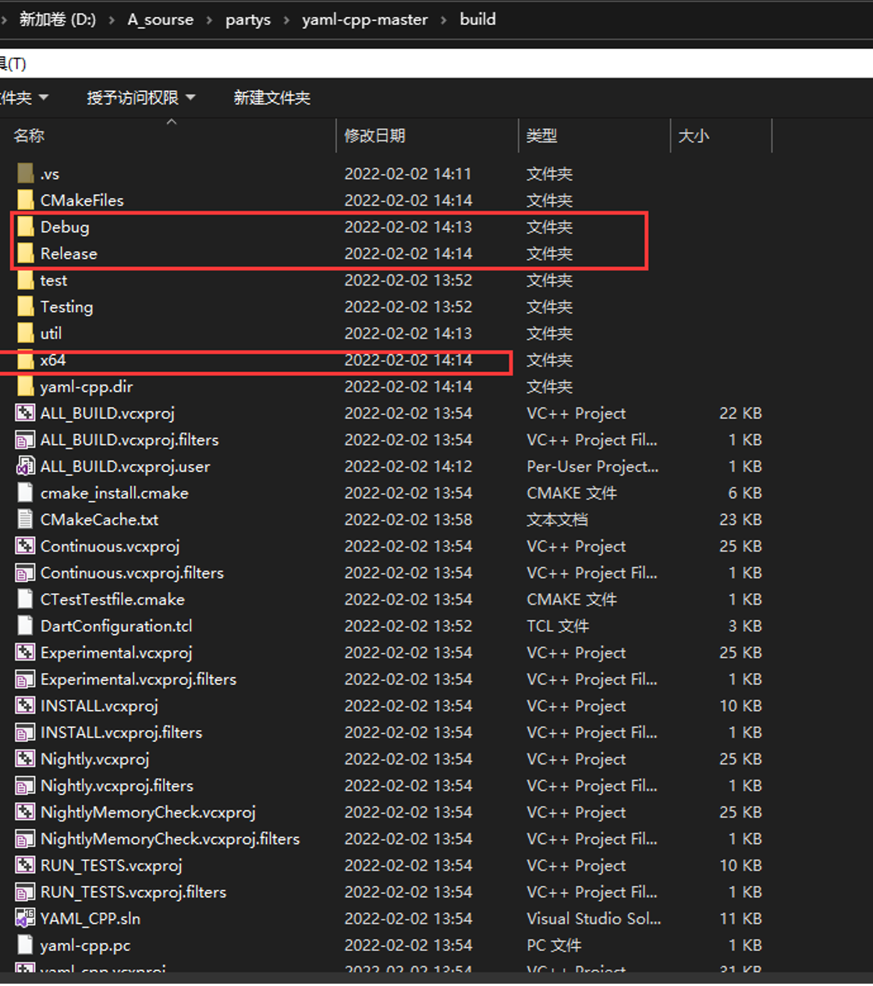

You can see that **yaml-cpp.lib** in the Release folder marks the completion of Build.

1. Use the yaml-cpp library: Copy the include directory of the yaml-cpp you just downloaded to the VS project

**Perform project configuration**: The following shows the configuration in DEBUG mode. The operation in release mode is basically the same.

Copy the generated lib file to the new lib folder,

Copy the dll file to the VS project directory (directory where *.vcxproj is located)

Next, configure the project properties of VS, **Linker**-**General**-**Additional Library Directory**, select the lib folder, and input “yaml-cppd.lib” in **linker**-**inpu**t; **C++ General**-**Additional Include Directory**: Select the path where the Include folder of YAML is located

5. Complete the yaml configuration and add yaml.h to the header file to complete the configuration.

